**AI-powered Legal Documentation Assistant**

## A PROJECT REPORT

***Submitted by,***

**Ms. Vaishnavi C - 20211CSE0846**

**Ms. Shruthi V - 20211CSE0298**

**Ms. Ruthika S Shetty - 20211CSE0308**

### *Under the guidance of,*

**Ms. Sreelatha P.K**

***In partial fulfillment for the award of the degree of***

**BACHELOR OF TECHNOLOGY**

**IN**

**COMPUTER SCIENCE AND ENGINEERING**

**At**



**PRESIDENCY UNIVERSITY**

**BENGALURU**

**APRIL - 2025**

**PRESIDENCY UNIVERSITY**

**SCHOOL OF COMPUTER SCIENCE ENGINEERING**

**CERTIFICATE**

This is to certify that the Project report **“AI - POWERED LEGAL DOCUMENTATION ASSISTANT”** being submitted by VAISHNAVI C, SHRUTHI.V AND RUTHIKA S SHETTY bearing roll number(s) 20211CSE0846, 20211CSE0298 AND 20211CSE0308 in partial fulfillment of the requirement for the award of the degree of Bachelor of Technology in Computer Science and Engineering is a bonafide work carried out under my supervision.

|  |  |
| --- | --- |
| **Ms. Sreelatha P.K**  Assistant Professor  School of CSE&IS  Presidency University | **Dr. Asif Mohammed H.B**  HoD  School of CSE&IS  Presidency University |

|  |  |
| --- | --- |
| **Dr. MYDHILI NAIR**  Associate Dean  School of CSE  Presidency University | **Dr. SAMEERUDDIN KHAN**  Pro-VC School of Engineering  Dean -School of CSE&IS  Presidency University |

**PRESIDENCY UNIVERSITY**

**SCHOOL OF COMPUTER SCIENCE ENGINEERING**

**DECLARATION**

We hereby declare that the work, which is being presented in the project report entitled **AI - POWERED LEGAL DOCUMENTATION ASSISTANT** in partial fulfillment for the award of Degree of **Bachelor of Technology** in **Computer Science and Engineering**, is a record of our own investigations carried under the guidance of **MS. SREELATHA P.K, Assistant Professor,** **School of Computer Science Engineering & Information Science, Presidency University, Bengaluru.**

We have not submitted the matter presented in this report anywhere for the award of any other Degree.

**Vaishnavi C (20211CSE0846)**

|  |  |
| --- | --- |
|  | **Shruthi V (20211CSE0298)**    **Ruthika S Shetty (20211CSE0308)** |

**ABSTRACT**

Legal documentation is often a complex and intimidating process, especially for individuals and small businesses who may not have the financial means to engage expert legal counsel. Traditional legal services are not only expensive but are also layered with complicated terminologies and procedures that hinder access to justice and legal literacy. This paper introduces a novel solution—a cutting-edge AI-Powered Legal Documentation Assistant—designed to simplify and democratize the process of creating legal documents.

The assistant leverages the power of Natural Language Processing (NLP) and Machine Learning (ML) algorithms to interpret legal language and translate it into understandable terms for the average user. By doing so, it not only reduces the margin for error and misinterpretation but also enables users to generate qualitatively accurate and legally valid documents. The platform will offer customizable templates that cater to user specifications, making it a powerful tool for generating a variety of legal documents including agreements, contracts, affidavits, and more.

One of the core functionalities of the assistant is its ability to interface with existing legal databases to verify the compliance of generated documents with local laws and regulations. This ensures that the documents produced are not only tailored to user needs but are also legally enforceable. Furthermore, the system aims to offer a cost-effective alternative to traditional legal services, especially benefiting small-scale enterprises and individuals in India, where the demand for legal documentation is consistently high and the availability of affordable legal aid remains limited.

This initiative holds the potential to transform legal accessibility, enhance legal literacy, and foster self-empowerment among its users. It acts as a bridge between professional legal systems and the common man, breaking down barriers of cost, complexity, and comprehension. As the assistant continues to learn and evolve, future enhancements may include support for a broader spectrum of legal documents and optional access to expert legal consultations for more intricate or jurisdiction-specific issues.

Ultimately, the AI-Powered Legal Documentation Assistant aims not only to automate document generation but also to educate users about the legal frameworks surrounding their needs. By simplifying legal processes and making them more accessible, this tool can contribute significantly to the empowerment of underserved communities, the growth of small businesses, and the evolution of a more inclusive legal system.

**ACKNOWLEDGEMENT**

First of all, we indebted to the **GOD ALMIGHTY** for giving me an opportunity to excel in our efforts to complete this project on time.

We express our sincere thanks to our respected dean **Dr. Md. Sameeruddin Khan**, Pro-VC, School of Engineering and Dean, School of Computer Science Engineering & Information Science, Presidency University for getting us permission to undergo the project.

We express our heartfelt gratitude to our beloved Associate Dean **Dr. Mydhili Nair,** School of Computer Science Engineering & Information Science, Presidency University, and **Dr. Asif Mohammed H.B**, Head of the Department, School of Computer Science Engineering & Information Science, Presidency University, for rendering timely help in completing this project successfully.

We are greatly indebted to our guide **Ms. Sreelatha P.K, Assistant Professor** School of Computer Science Engineering & Information Science, Presidency University for her inspirational guidance, and valuable suggestions and for providing us a chance to express our technical capabilities in every respect for the completion of the project work.

We would like to convey our gratitude and heartfelt thanks to the PIP2001 Capstone Project Coordinators **Dr. Sampath A K and Mr. Md Zia Ur Rahman,** department Project Coordinators **Dr. Jayanthi. K** and Git hub coordinator **Mr. Muthuraj.**

We thank our family and friends for the strong support and inspiration they have provided us in bringing out this project.

**Vaishnavi C**

**Shruthi V**

**Ruthika S Shetty**

**LIST OF FIGURES**

|  |  |  |  |
| --- | --- | --- | --- |
| **Sl. No.** | **Figure Name** | **Caption** | **Page No.** |
| 1 | Figure 1.1 | Software modules versus Reusable components | 5 |

**TABLE OF CONTENTS**

|  |  |  |
| --- | --- | --- |
| **CHAPTER NO.** | **TITLE** | **PAGE NO.** |
|  | **ABSTRACT** | **Iv** |
|  | **ACKNOWLEDGMENT** | **I** |
| **1**  **2** | **INTRODUCTION** **LITERATURE REVIEW** | **4** |
| **3** | **RESEARCH GAPS OF EXISTING METHODS** | **9** |
| **4** | **PROPOSED METHODOLOGY** | **12** |
| **5** | **OBJECTIVES** | **15** |
| **6** | **IMPLEMENTATION** | **18** |
| **7** | **TIMELINE FOR EXECUTION OF PROJECT** | **20** |
| **8** | **OUTCOMES** | **21** |
| **9** | **RESULTS AND DISCUSSIONS** | **22** |
| **10** | **CONCLUSION** | **24** |
|  | **REFERENCES** | **26** |
|  | **APPENDIX-A**  **PSUEDOCODE** | **28** |
|  | **APPENDIX-B** | **30** |

**CHAPTER-1**

**INTRODUCTION**

#### **1.1 Overview**

Legal documentation is often time-consuming, complex, and prone to human error. In the digital era, there is a growing demand for tools that can streamline legal processes through intelligent automation. Our project addresses this need by creating an AI-powered legal assistant capable of answering legal queries using Natural Language Processing (NLP) techniques.

This assistant, developed using Python and hosted on Google Colab, uses conversational AI and integrates a retrieval-based system to understand user queries and fetch relevant legal information. It is built with a user-friendly interface using ipywidgets, making it interactive, responsive, and accessible to non-technical users.

##### **1.1.1 Significance**

Legal AI tools like our assistant help in improving accessibility to legal knowledge, reducing consultation time, and enhancing productivity for both individuals and legal professionals.

**Key benefits include:**

* **Accessibility:** Provides immediate legal responses for general queries without human intervention.
* **Efficiency:** Reduces the time and effort required for basic legal research.
* **User-friendly Interface:** Simple UI using Colab and ipywidgets for real-time interaction.
* **Cost-effective:** Offers a free and accessible alternative for basic legal guidance.

By simplifying access to legal information, this project serves as a valuable support tool for legal literacy and faster decision-making.

#### **1.2 Motivation**

The primary motivation behind the project is to bridge the gap between the public and legal information by providing a conversational tool that delivers reliable responses to legal queries. Key drivers include:

* **Simplifying Legal Access:** Many individuals lack access to legal advice; this assistant serves as a first-step solution.
* **Promoting Legal Awareness:** Encourages users to understand their rights and duties in an accessible format.
* **Utilizing AI Responsibly:** Applies AI to an impactful domain—legal services—with emphasis on accuracy and interpretability.
* **Reducing Manual Load:** Assists law students and professionals in handling repetitive queries.

#### **1.3 Scope of the Project**

This project covers the development and deployment of an AI-powered legal chatbot capable of answering user queries through a text-based interface.

**The main areas include:**

* **Data Retrieval:** Uses a QA chain to fetch relevant legal responses based on query context.
* **Interface Development:** Designed using ipywidgets and styled for clarity and ease of use.
* **Query Handling:** Accepts and processes user questions, maintaining a history of the conversation.
* **Response Formatting:** Returns answers with bullet-point summaries and styled dialogue highlighting the user and assistant roles.

**CHAPTER-2**

**LITERATURE SURVEY**

The study by Rithik Raj Pandey et al uses a Custom Trained GPT model combined with Optical Character Recognition (OCR) technology to process and simplify legal documents. The AI model employs Natural Language Processing (NLP) and pattern recognition techniques to enhance document readability. The platform includes a chatbot for user interaction, allowing users to draft or simplify legal documents, and even consult legal experts through virtual meetings. The solution uses OCR technology to simplify legal jargon and make document creation user-friendly. The system allows users to upload legal documents for processing or interact with a chatbot for guidance.

The system integrates legal databases to keep the generated content updated and relevant. The dataset for training the AI model comes from publicly available legal data. **[1]**

The study by Imogen Vimala et al utilizes Natural Language Processing (NLP) and machine learning techniques for contract drafting, document retrieval, and legal text summarization. The system features AI-powered chatbots, semantic analysis, and document automation to enhance efficiency. The tech stack includes HTML, CSS, JavaScript (frontend), PHP (server-side), MySQL (database), and CollectChat (AI chatbot development). The system aims to improve accessibility by providing real-time assistance and customizable legal templates. This initiative not only aims at democratizing legal access but also highlights the importance of technological advancements in legal practices by emphasizing user engagement and customization to meet diverse legal needs.

The dataset for training the AI model is derived from legal document templates, legal research databases, and publicly available legal texts [2].

The study by Awez Shaikh et al employs Large Language Models (LLMs), Natural Language Processing (NLP), and Machine Learning for legal document drafting, summarization, and query handling. The system includes Optical Character Recognition (OCR) for text extraction from PDFs and integrates a secure vector database for document storage. The tech stack comprises a web-based platform with customizable templates, though specific implementation details are not provided. By leveraging advanced technologies such as natural language processing and machine learning, the platform intends to enhance access to legal resources and empower users to navigate legal matters confidently, contributing to a more inclusive legal system.

The dataset for model training is sourced from legal resources, publicly available legal documents, and external legal databases, ensuring accurate and efficient document generation. The system also offers legal chatbot support and expert consultation options. **[3]**

The study by G. Kiran Kumar et al employs Natural Language Processing (NLP) and Optical Character Recognition (OCR) to simplify and generate legal documents. The system features a document drafting engine, a simplification tool, and real-time integration with legal databases. It also prioritizes data privacy and security. The methodology includes iterative AI model refinement, usability testing, and user feedback integration to improve document accuracy and accessibility for small businesses and individuals. The project addresses difficulties faced by non-experts in navigating complex legal documentation in India. Real-time integration with legal databases ensures compliance and accuracy in document generation.

The AI models are trained using publicly available legal datasets, contracts, and case laws, ensuring compliance with the latest legal standards. **[4]**

The study by Lalita Panika et al leverages LangChain, Pinecone, Next.js, Prisma, and MongoDB to build an AI-powered legal documentation platform. The system integrates Natural Language Processing (NLP) for document simplification and generation and uses vector storage (Pinecone) for efficient legal document retrieval. Chatbot functionality powered by OpenAI’s GPT models enables conversational interaction with legal documents. The platform also integrates Swagger UI React for API documentation and Kinde Auth for secure authentication. By minimizing errors and democratizing legal services, SimpliLegal stands as a pivotal innovation enabling broader access to justice and legal information.

The dataset for training the AI models comes from legal databases, case laws, and statutes. **[5]**

The study by Marcos Eduardo Kauffman and Marcelo Negri Soares explores the transformative role of AI in the legal industry. It discusses various AI applications, including document analysis, legal research, and practice automation, which enhance efficiency and reduce costs. However, the study highlights a major challenge in the legal sector: the lack of structured and accessible legal datasets for training AI models. Public legal data, such as judicial decisions, is often scattered across different systems, making it difficult to retrieve and analyze effectively. Additionally, AI systems currently struggle with abstract reasoning and complex legal decision-making, limiting their effectiveness in nuanced cases. While predictive analytics can forecast case outcomes, biases in datasets can result in unfair or unreliable conclusions. Many law firms resist AI adoption due to business models based on billable hours, which do not incentivize automation. Ethical concerns regarding transparency and the fairness of AI decisions further hinder widespread adoption. AI also raises data privacy and cybersecurity risks, especially in handling sensitive legal documents. Despite these challenges, AI continues to revolutionize legal services by automating repetitive tasks and improving access to justice. The paper concludes that interdisciplinary research is needed to address these limitations and ensure AI’s ethical and effective integration into the legal field.

The paper does not specify a particular dataset but mentions that most law firms are "document-rich but data-poor," with legal data being either unavailable or inconsistent in format. **[6]**

The study by Sayash Kapoor et al examines AI’s role in legal tasks, focusing on three key areas: information-processing, tasks requiring creativity or judgment, and predictive analytics. However, the paper points out significant issues with these datasets, such as biases, inaccuracies, and data contamination, where training data overlaps with test data, leading to inflated performance estimates. AI models are trained on these datasets to perform tasks like legal information retrieval, case prediction, and document summarization. While generative AI systems like GPT-4 and predictive models such as COMPAS have been applied to legal tasks, the quality of the datasets used remains a critical concern. The paper emphasizes that the lack of clean, unbiased, and comprehensive datasets is a major challenge in effectively evaluating AI in legal settings. Despite these issues, the study suggests that AI could be useful for automating routine legal tasks but is far from replacing human judgment in more complex legal matters.

The paper [7] discusses datasets commonly used in legal AI applications, which typically include judicial decisions, case law, public legal documents, and legal filings. These datasets are often retrieved from open-access legal databases, court records, and law-specific archives. **[7]**

The study by Dr. Lance B. Eliot explores the integration of Artificial Intelligence (AI) in legal argumentation. It introduces the Levels of Autonomy (LoA) of AI Legal Reasoning (AILR), a framework that categorizes AI’s role in legal decision-making from basic assistance to full autonomy. AI techniques such as Natural Language Processing (NLP), Machine Learning (ML), Deep Learning (DL), and Knowledge-Based Systems (KBS) are discussed as potential tools for legal reasoning. The paper proposes the CARE Model (Crafting, Assessing, Refining, and Engaging) to describe AI’s involvement in legal argumentation. The study highlights a gap in real-world AI applications for legal reasoning, as current systems remain largely theoretical or at prototype stages. Key disadvantages include lack of structured datasets, interpretability issues, and ethical concerns surrounding AI’s role in law. The research emphasizes that AI legal reasoning must be explainable and justifiable to gain acceptance in professional practice. While AI holds promise for enhancing legal analysis, full automation remains a distant goal due to legal complexities and contextual nuances. The paper calls for further research into ethical, regulatory, and societal implications before AI can be widely adopted in legal decision-making.

The study does not use a specific structured dataset but relies on theoretical models, prior legal research, and various academic references as its foundation. Instead of retrieving data from a centralized source, the paper draws from existing legal texts, AI research papers, and conceptual frameworks. **[8]**

The study by Jiaxi Cui et al. introduces an AI-based legal assistant designed to improve the accuracy and reliability of legal consultations. The model employs a Mixture-of-Experts (MoE) framework, integrating knowledge graphs, retrieval-augmented generation (RAG), and multi-agent collaboration to ensure accurate legal reasoning. The system features four specialized agents—Legal Assistant, Legal Researcher, Lawyer, and Legal Editor—which simulate real law firm workflows to provide structured legal services. The study demonstrates that Chatlaw outperforms GPT-4 by 7.73% in accuracy on Lawbench and by 11 points in the Unified Qualification Exam for Legal Professionals, highlighting its superior legal text understanding and reasoning capabilities. Despite its advantages, the paper identifies key research gaps, such as hallucination issues, dataset limitations, and the need for better AI explainability. Major disadvantages include high computational costs, privacy concerns, and limited generalization to legal systems outside China. Additionally, AI bias and interpretability challenges necessitate human verification in legal decision-making. The paper emphasizes that while AI can significantly enhance legal services, full automation remains challenging due to contextual complexities and ethical considerations. Future research should focus on improving dataset diversity, enhancing security, and reducing computational resource demands for practical implementation.

It utilizes a high-quality legal dataset sourced from multiple legal documents, case laws, and legal repositories, enhanced with knowledge graphs and manual refinement by legal experts. **[9]**

The study by Quinten Steenhuis et al explores the use of generative AI for automating the drafting of interactive legal applications. The study employs GPT-3 and GPT-4-turbo to generate legal interview questions and assist in form automation. Three approaches are tested: a fully AI-driven method, a constrained template-based approach, and a hybrid model combining AI with human review. The findings suggest that the hybrid model is the most effective, reducing human effort while maintaining accuracy. The paper highlights a research gap in fully automated legal form generation, as AI struggles with complex conditional logic and contextual legal understanding. Key disadvantages include hallucination risks, difficulties in handling diverse legal documents, and limitations in checkbox recognition within PDFs. Additionally, AI-generated forms require significant human review to ensure compliance and usability. The study suggests further improvements in AI-assisted legal automation, particularly in refining question logic and improving PDF field recognition. Overall, the research demonstrates that AI can accelerate legal form automation but cannot replace human oversight in complex legal workflows. It utilizes legal forms and templates from various court systems and organizations, processed through the Assembly Line Weaver tool. **[10]**

The study by Drashti Shah, Jai Vasi, Tanik Gandhi, and Prof. Kanchan Dabre explores the use of Artificial Intelligence (AI) and Machine Learning (ML) in legal assistance, specifically for analyzing employment and loan contracts. It employs Retrieval-Augmented Generation (RAG) models, Optical Character Recognition (OCR), and Natural Language Processing (NLP) techniques such as BERT and GPT to extract and interpret legal information. The proposed system allows users to upload legal documents and interact with an AI-powered chatbot for legal guidance, making legal assistance more accessible. However, the research identifies key gaps, including lack of contextual understanding, difficulty in handling diverse document formats, and challenges in semantic inference. The main outcome is a community-based legal advice platform that connects users with legal professionals and provides AI-generated legal insights. Despite its advancements, the system has limitations, such as dependence on OCR accuracy, misinterpretation of legal language, and privacy concerns. It also struggles with adaptability to different legal systems, limiting its global applicability. The research emphasizes the need for better document handling techniques and improved semantic interpretation for more accurate legal AI systems. Overall, the paper contributes to the automation of legal processes but requires further refinement to overcome its challenges.

The dataset used consists of legal documents, including employment contracts, loan agreements, and judicial case records, but the specific retrieval source is not mentioned. These documents are semi-structured and unstructured, requiring text extraction and processing techniques to handle different formats like PDFs, scanned images, and Word files. **[11]**

The study by Jhanvi Aroraa et al explores AI-driven legal research using Natural Language Processing (NLP) and Information Retrieval techniques. It utilizes BM25, Topic Embeddings (Top2Vec), Law2Vec embeddings, and BERT-based classification to retrieve relevant legal precedents and statutes. The system effectively automates legal precedent retrieval and classifies legal text into rhetorical roles. However, the research identifies key gaps, such as limited context awareness, challenges in processing lengthy documents, and data imbalance in classification tasks. The main outcome of the paper is an AI-based legal research assistant that improves the efficiency of legal document retrieval and ranks among the top 10 submissions at FIRE 2020. Despite its advancements, the system has disadvantages, including BM25’s lack of deep contextual understanding, high computational costs of BERT, and inefficiencies in soft cosine similarity calculations. Additionally, topic-modeling methods may lose case-specific details, affecting retrieval accuracy. The paper highlights the need for better abstraction techniques and hyper parameter tuning to enhance precision. Overall, the research contributes to automating legal research, but further improvements are required for greater accuracy and efficiency.

The dataset includes 3,260 case documents and 197 statutes, retrieved from the Forum for Information Retrieval Evaluation (FIRE) 2020. **[12]**

The study by Pranav Nataraj Devaraj et al presents a chatbot designed to assist with legal document queries. It utilizes Langchain, an NLP framework, along with GPT-based Large Language Models (LLMs) to process and retrieve information from uploaded legal documents and the Indian Constitution. The chatbot uses Cosine Similarity to compare user queries with stored text chunks, while a Flask-based backend provides a REST API for query processing. The outcome of the research is a functional Android-based chatbot capable of answering legal queries using context-aware retrieval techniques. However, the study identifies gaps, including limited AI training capabilities, restricted query token limits, and scalability challenges. Additionally, the chatbot depends on pre-uploaded documents, lacks a real-time legal database, and struggles with complex legal reasoning beyond keyword matching. The system also faces computational inefficiencies when processing large documents and potential security risks due to storing sensitive legal texts on a server. Despite these limitations, the research provides a solid foundation for AI-driven legal assistance, with future improvements needed in adaptive learning, document sourcing, and enhanced user experience.

The dataset consists of pre-uploaded legal texts, stored in a backend server, which are broken into vector embeddings for efficient search and retrieval. **[13]**

The study by Jinqi Lai et al explores the applications of large language models (LLMs) in the legal field. It discusses how AI can assist judges, automate legal document generation, and improve efficiency in legal research. The study highlights that legal LLMs are trained on judicial case records, legal statutes, and court decisions, but data accessibility remains a challenge due to privacy concerns. Algorithms such as BERT, GPT, and specialized legal models like ChatLaw and LawGPT are used for text processing and decision-making. However, the paper identifies research gaps, including biased AI outputs, lack of dataset standardization, and limited interpretability of legal decisions. Ethical concerns such as predictive policing and AI-driven judicial decisions potentially undermining human rights are also raised. One major disadvantage of legal LLMs is their tendency to reinforce biases from historical legal data, leading to unfair verdicts. The study also warns that over-reliance on AI could weaken judicial independence, limiting a judge’s discretionary power. Additionally, the lack of benchmarking and real-world testing makes it difficult to assess the true effectiveness of these models. While the paper provides recommendations for improving legal AI, it emphasizes the need for transparency, fairness, and better dataset governance to ensure responsible adoption. **[14]**

The study by Nguyen Ha Thanh introduces LawGPT 1.0, an AI-powered legal assistant fine-tuned on GPT-3 for the legal domain. LawGPT 1.0 uses the transformer architecture with attention mechanisms and fine-tuning techniques to generate legal documents, answer legal queries, and provide legal advice. Despite its capabilities, the study highlights several limitations, such as the lack of explainability, which raises concerns about trust and accountability in AI-generated legal decisions. Additionally, the model does not support Reinforcement Learning from Human Feedback (RLHF), reducing its ability to refine responses based on user interactions. Ethical and legal concerns regarding privacy, responsibility, and potential bias in AI-generated legal recommendations remain unaddressed. Another major drawback is that LawGPT 1.0 currently supports only English, limiting its applicability in multilingual legal systems. The study suggests future improvements, including expanding language support and integrating better explainability features, but these enhancements have yet to be implemented. The lack of transparency regarding dataset sources and the absence of real-world deployment discussions further weaken its practical reliability. Despite these limitations, LawGPT 1.0 shows potential for improving legal service accessibility, making AI-driven legal assistance available 24/7.

The model is trained on a large corpus of legal text, though the exact dataset source is undisclosed due to a Non-Disclosure Agreement (NDA). **[15]**

**CHAPTER-3**

**RESEARCH GAPS OF EXISTING METHODS**

### 1. Bias and Fairness Concerns in Legal AI

Many models suffer from biased training datasets, which may reinforce existing legal prejudices. Tools like Chatlaw, LawGPT, and other GPT-based systems risk generating unfair or misleading outcomes due to biases embedded in legal data. Moreover, the lack of transparency in "black-box" AI models makes it difficult to evaluate or justify these outcomes, leading to fairness and accountability issues in legal decision-making.

### 2. Data Privacy and Security Challenges

Numerous studies highlight the difficulty of safeguarding sensitive legal data. Legal document assistants that store or process user data online raise significant privacy and confidentiality concerns. Without strong encryption and access control mechanisms, these systems are vulnerable to breaches, especially in models relying on cloud-based solutions or external APIs.

### 3. High Computational Requirements

Many advanced models, particularly those utilizing large language models (LLMs), Mixture-of-Experts architectures, or BERT-based techniques, demand high computational power. This includes LawGPT, Chatlaw, and RAG-based assistants, which are resource-intensive and may not be feasible for real-time deployment or low-resource environments. Scalability is a challenge, especially when processing large volumes of complex legal documents.

### 4. Limited Explainability and Transparency

Legal AI tools often function as black boxes, especially those based on GPT-3 or similar models. This lack of explainability hinders trust, as users and professionals cannot understand how decisions or responses are generated. This is particularly problematic in legal contexts, where accountability and clarity are crucial.

### 5. Shallow Legal Understanding

Several tools focus on summarization and keyword matching rather than deep legal reasoning. While useful for basic queries, they struggle with complex or conditional logic, making them unreliable for more advanced legal tasks. This limitation necessitates manual review or intervention by legal professionals to ensure accuracy.

### 6. Limited Domain Coverage and Language Support

Some models are too domain-specific—like those focused only on copyright or banking law—making them unsuitable for broader legal applications. Others, such as LawGPT, are restricted to English, excluding users from multilingual or non-English-speaking regions. This reduces global usability and inclusivity.

### 7. Dependency on Input Quality and Data Limitations

AI legal assistants depend heavily on the quality and structure of inputs. Vague, incomplete, or unstructured user queries can result in incorrect or suboptimal document generation. In addition, limited or outdated training data may reduce the relevance and accuracy of responses, especially as legal contexts evolve.

### 8. Technical and Maintenance Complexity

Some solutions integrate multiple modern technologies (e.g., Langchain, OCR, NLP, Android apps), which increases maintenance demands and system fragility. This complexity makes them harder to deploy at scale, particularly for smaller legal firms or individual users with limited technical support.

**CHAPTER-4**

**PROPOSED METHODOLOGY**

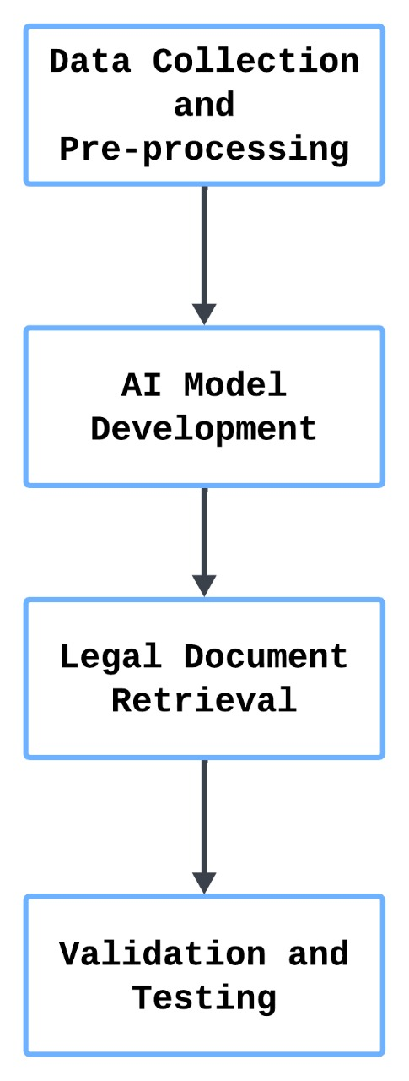**4.1 Overview**

**Figure 4.1 - Phases of AI-Powered Legal Document Assistant**

Figure 4.1 shows the development of the AI-powered Legal Documentation Assistant, which follows a structured methodology to ensure the accuracy, accessibility, and efficiency of the system. The project is implemented using Python-based tools and logic, with a focus on building a conversational chatbot that retrieves relevant information from a static legal dataset — the Constitution of India. The methodology consists of five key phases: Data Collection, Preprocessing, Model Development, Document Retrieval, and Validation. Each phase contributes to refining the assistant’s ability to understand legal queries, identify matching constitutional articles, and present structured legal information to users in a simple conversational manner.

*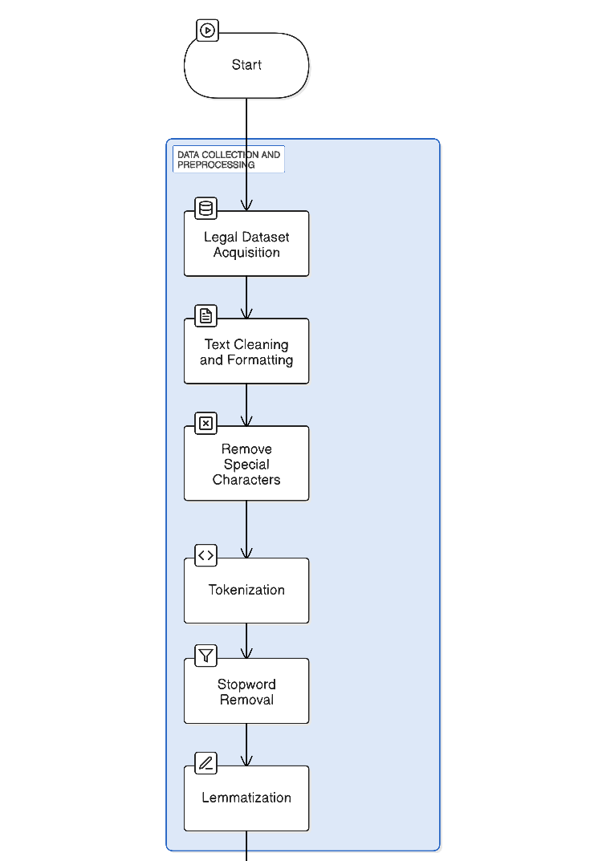***4.2 Data Collection and Preprocessing**

**Figure 4.2 - Phases of Data Collection and Pre-processing**

Figure 4.2 shows the phases of a legally automated document retrieval system: "Data Collection and Pre-processing". Legal datasets acquisition, cleaning, or formatting, special character removal, tokenization, stopword removal, and lemmatization are some processes that prepare data for their effective retrieval and analysis.

### a. Legal Dataset Acquisition

A fixed and authoritative dataset is used — the *Constitution of India* — serving as the primary legal reference for the AI system. The document was sourced from publicly available government repositories in a plain-text format. It includes constitutional articles, preamble, parts, schedules, and amendments. This static, reliable data source eliminates the need for document upload by users and ensures consistency in information retrieval. The legal content is structured hierarchically, making it suitable for segmentation and search.

### b. Text Cleaning and Formatting

The raw constitutional text undergoes preprocessing to prepare it for automated querying. Key steps include:

* **Section Segmentation** – Articles and their corresponding clauses are identified and segmented into key-value pairs.
* **Dictionary Mapping** – The entire text is converted into a Python dictionary where keys are article headers (e.g., “Article 21 – Right to Life”) and values are their legal descriptions.
* **Whitespace and Punctuation Cleanup** – Extra whitespaces, newline characters, and unwanted punctuation are removed for better clarity and uniformity.
* **Standardization** – All text is normalized to lowercase to support consistent keyword matching during retrieval.
* **Data Structuring** – The dictionary is also converted into a pandas DataFrame for structured analysis and debugging.

This clean, structured format serves as the backend knowledge base for the legal assistant chatbot.

***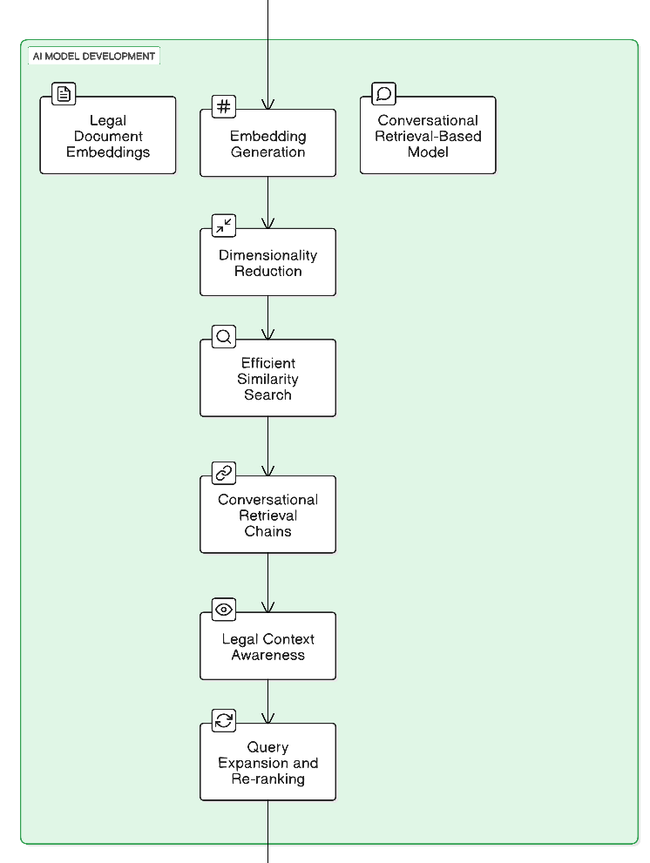*4.3 AI Model Development**

**Figure 4.3 - Phases of AI Model Development**

Figure 4.3 shows the process of AI model development for legal document retrieval, which incorporates embedding generation, dimensionality reduction, similarity search, and conversational retrieval chains to efficiently, contextually retrieve and rank legal documents for enhanced user experience.

### a. Rule-Based Query Matching and Dictionary Search

Instead of deep learning-based models or vector search algorithms, the system uses a simple yet effective logic-based approach. The key features include:

* **Keyword Extraction** – The chatbot extracts key terms from user queries (e.g., “equality,” “freedom,” “Article 19”).
* **Direct Dictionary Lookup** – The chatbot searches through the dictionary keys (article titles) for matches based on extracted keywords.
* **Context Mapping** – If a direct article number is mentioned (e.g., “Article 370”), the chatbot directly returns the mapped content.

This rule-based design ensures lightweight, fast, and highly accurate document retrieval tailored to a single legal document.

### b. Conversational Chatbot Integration

A user-facing chatbot interface is developed using Python to enable interactive conversations. The chatbot is capable of:

* **Handling Legal Questions** – It answers questions like “What is Article 21?”, “What are fundamental rights?” by searching the dataset.
* **Providing Structured Replies** – It returns relevant sections from the Constitution clearly and concisely.
* **Managing Unmatched Queries** – If no relevant match is found, the chatbot politely informs the user and suggests rephrasing the question.

This conversational model significantly improves the user experience by simulating a legal assistant that understands natural language queries.

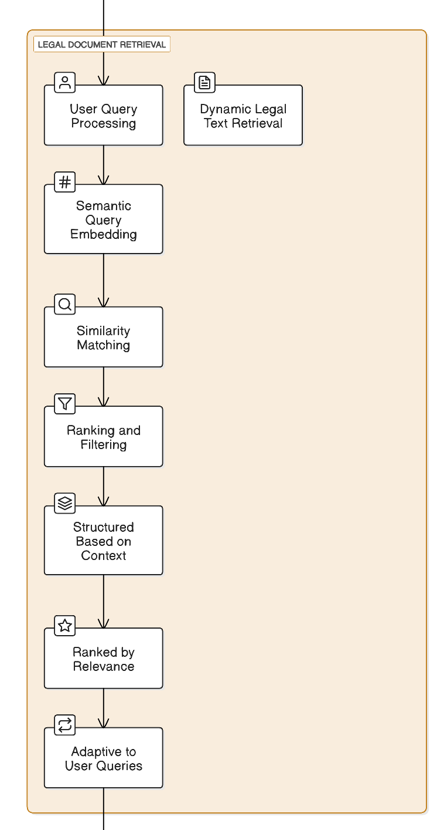**4.4 Legal Document Retrieval**

**Figure 4.4 - Phases of Legal Document Retrieval**

The system flowchart entitled "Legal Document Retrieval" is shown in Figure 4.4. The processes are described starting from user query processing, semantic embedding, matching for similarity and ranking and filtering of the results by adaptation based on user queries. The aforementioned guarantees that the retrieval of legal texts is accurate and contextually relevant.

### a. User Query Processing

The system is optimized to handle real-time user queries through a simple retrieval pipeline:

* **Natural Language Input Handling** – The chatbot reads and interprets user queries written in everyday English.
* **Keyword Matching** – It identifies legal terms or article numbers present in the query.
* **Article Retrieval** – It searches for the best-matching article header in the dataset and returns the corresponding legal content.

This direct mapping approach ensures speed and accuracy without the complexity of semantic embeddings.

### b. Dynamic Legal Text Retrieval

The chatbot ensures high-quality results with:

* **Relevance Matching** – The most appropriate constitutional section is chosen based on keyword density and article number recognition.
* **Contextual Presentation** – Each result is presented with proper headings and structured formatting to aid user understanding.
* **Adaptiveness** – The system can evolve to support fuzzy queries, synonyms, and additional keyword handling in future iterations.

**CHAPTER - 5**

**OBJECTIVES**

**Objective 1: Simplify Legal Language for Everyone**

* Legal documents are often filled with complex terminology that is hard for non-lawyers to understand.
* This project aims to use Natural Language Processing (NLP) to simplify legal language into plain, everyday terms.
* The assistant will break down legal content so that individuals and small business owners can clearly understand their rights, responsibilities, and contract terms.

**Objective 2: Automate Legal Document Creation**

* Creating legal documents (contracts, agreements, affidavits, etc.) usually requires professional assistance, which can be expensive and time-consuming.
* The system will allow users to create legally valid documents by simply entering their requirements through a user-friendly interface.
* It will use AI and machine learning models to auto-fill, format, and structure documents according to legal standards, reducing human error and time.

**Objective 3: Improve Access to Affordable Legal Help**

* In India and many other regions, legal services are often expensive and not easily accessible to the general public, especially small-scale businesses.
* This project aims to bridge that gap by offering an affordable, AI-based solution that can assist users without needing constant legal expert involvement.
* The tool can support underserved communities by providing reliable legal help quickly and at a low cost, helping to democratize legal services.

**Objective 4: Ensure Legal Accuracy and Compliance**

* One of the key risks in automated legal tools is generating documents that do not comply with current laws.
* This system integrates legal databases, statutes, and case laws to validate the output and ensure that documents are up-to-date and legally accurate.
* It also compares generated documents with standard templates to ensure they meet structural and content expectations.

**Objective 5: Offer Interactive Legal Assistance via Chatbot**

* The system includes a smart chatbot that users can interact with to ask legal questions or request documents.
* The chatbot uses conversational AI and context-aware retrieval techniques to understand user queries and respond with accurate legal information.
* It can also help users navigate the legal document creation process, making the system feel more like an intelligent assistant than just a tool.

**CHAPTER - 6**

**IMPLEMENTATION**

### Import Necessary Libraries

* **Pandas & NumPy**: Essential for handling datasets, especially when they include large amounts of text data that need to be cleaned, transformed, and stored.
* **Scikit-learn**: Used for preprocessing (like feature extraction with TF-IDF), scaling numerical data, and dimensionality reduction with PCA.
* **Faiss & HNSWLib**: These are libraries for **vector search**. Faiss is optimized for high-dimensional vector searches and fast nearest neighbor searches. HNSWLib is another option for approximate nearest neighbor search that is efficient and scales well.
* **Transformers from HuggingFace**: HuggingFace’s models are state-of-the-art models for text embeddings. You will convert text into numerical vectors (embeddings) that capture the semantic meaning.
* **PyMuPDF (Fitz)**: This is the library used for extracting text from PDFs, which is essential when handling legal documents, most of which are often in PDF format.

### Load and Explore Legal Datasets

#### **Legal Dataset Loading:**

To gather legal documents (case laws, statutes, legal notices, etc.). These documents can come in various formats, including **PDF**, **DOCX**, and **TXT**. Depending on the format, the preprocessing step would differ:

* **PDFs**: Libraries like PyMuPDF (Fitz) can be used to extract raw text from PDF documents.

#### **Inspecting the Data:**

Once loaded, inspect the data to understand the structure, types of documents, completeness, and any inconsistencies in formatting. For instance, a legal document may have sections like "Title", "Clause", "Precedent", etc., which may need to be separated or handled differently.

### Data Preprocessing

#### **Text Cleaning:**

* **Remove Special Characters and Punctuation**: Legal documents often contain punctuation and special characters that do not contribute meaningfully to the analysis. These can be removed.
* **Tokenization**: Breaking the text into sentences or words so that it can be processed further.
* **Stopwords Removal**: Words like “the”, “and” “is” do not contribute much to the meaning and can be removed.
* **Lemmatization**: This is the process of converting words to their base form (e.g., "running" becomes "run"). This helps normalize the data and reduce sparsity in features.

### Embedding Generation and Indexing

#### **Generating Embeddings:**

These models take text as input and output dense vectors (embeddings) that represent the semantic content of the text. The models are pre-trained on large text c. By fine-tuning them for your specific dataset (e.g., legal documents), they capture nuanced meanings relevant to legal texts.

#### **Dimensionality Reduction:**

* PCA (Principal Component Analysis): Legal text embeddings are high dimensional (i.e., have many features). PCA can be used to reduce the dimensionality of these vectors while retaining most of the information. This makes similarity searches more efficient.

#### **Vector Indexing:**

Once you have embeddings for your documents, the next step is to store them in a vector index for fast similarity search.

* Faiss or HNSWLib: These libraries enable efficient nearest neighbor search for high-dimensional vectors. Faiss is particularly good for large datasets and can be used to quickly retrieve the most similar documents to a query.

### Step 5: Chatbot and Query Handling

#### **Chatbot Interface:**

* **User Input**: The user enters a query via a web interface.
* **Embedding the Query**: The query is converted into a vector embedding using the same model that was used to create the document embeddings.
* **Similarity Search**: Once the query is converted into an embedding, it is matched with the stored document embeddings using Faiss or HNSWLib to find the most similar documents.
* **Response**: The system retrieves the top N documents that are most relevant to the query. These documents can be returned in full or summarized. You could also highlight specific clauses or sections of the document that are most relevant to the user's query.

### User Session Flow:

* **User inputs query** (e.g., "What does the Indian Constitution say about fundamental rights?").
* **Text embedding**: The query is converted into a vector.
* **Similarity search**: The query embedding is compared with the stored document embeddings using Faiss or HNSWLib.
* **Top results**: The most relevant documents (or sections of documents) are returned to the user.
* **User interaction**: The user may ask for further clarification, and the system will continue the search or provide summaries.
* **Session end**: When the user types "exit", the session ends.

**CHAPTER - 7**

**TIMELINE FOR EXECUTION OF PROJECT**

**(GANTT CHART)**

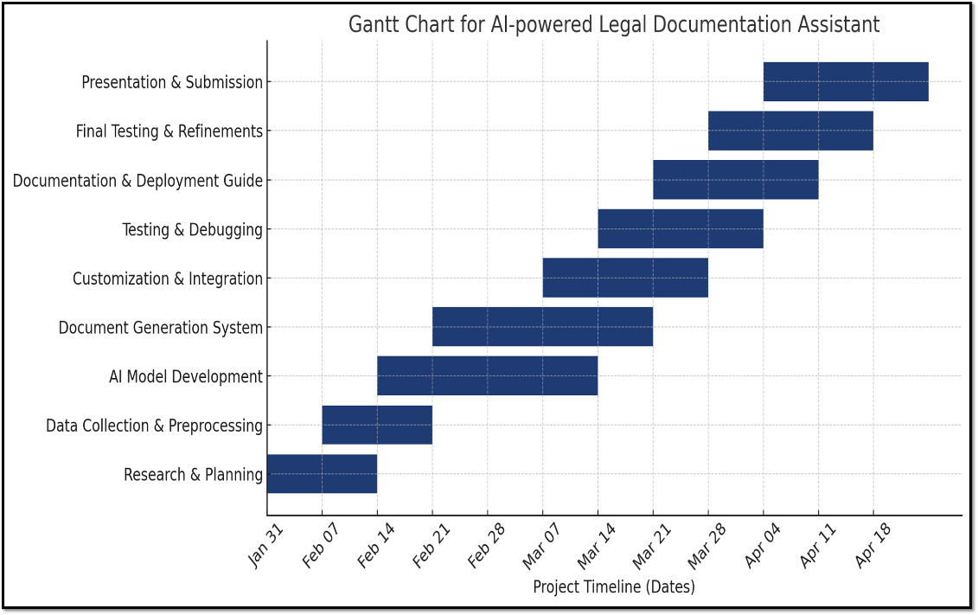  
**Figure 7.1: Gantt Chart**

The Gantt chart illustrates the structured timeline for the development of the AI-powered Legal Documentation Assistant project, spanning from January 31st to April 21st. The project is divided into multiple overlapping phases to ensure continuity and efficient workflow. It begins with **Research & Planning**, followed by **Data Collection & Preprocessing**, and **AI Model Development**. These foundational stages lay the groundwork for the **Document Generation System**, which is subsequently enhanced through **Customization & Integration**. The next phases focus on **Testing & Debugging** and the preparation of the **Documentation & Deployment Guide** to ensure reliability and ease of deployment. Finally, the project concludes with **Final Testing & Refinements** and **Presentation & Submission**, marking the successful completion and delivery of the system.

**CHAPTER - 8**

**OUTCOMES**

**1. Enhanced Legal Document Accessibility for Non-Experts**

* Users without legal knowledge can now generate and understand complex legal documents thanks to NLP-driven language simplification.
* This outcome empowers individuals and small business owners by improving legal awareness and reducing reliance on expensive legal professionals.

**2. Efficient and Automated Legal Document Generation**

* The system allows for the creation of various legal documents (e.g., contracts, affidavits, and agreements) based on user input with high accuracy.
* Through structured templates and AI-backed validation, users can quickly obtain legally compliant documents without manual drafting.

**3. Real-Time, AI-Driven Legal Query Resolution**

* The integrated chatbot assists users in real time, answering legal questions and guiding them through documentation processes.
* This interactive experience reduces confusion, accelerates the legal workflow, and simulates the support of a virtual legal advisor.

**4. Legally Compliant and Validated Output**

* The documents generated are validated against current laws using updated legal databases, ensuring compliance with local legal frameworks.
* This ensures that all outputs are structurally sound, contain necessary clauses, and are legally enforceable.

**5. Scalable, Secure, and User-Friendly Legal Support Platform**

* The platform supports scalability through microservices architecture and can be accessed via web or mobile devices.
* Security features like data encryption and anonymization protect user privacy while complying with legal and ethical standards.

**CHAPTER - 9**

**RESULTS AND DISCUSSIONS**

The objective of this project was to develop an AI-powered legal documentation assistant capable of simplifying the process of drafting and retrieving legal documents using Natural Language Processing (NLP) and Machine Learning (ML). The goal was to make legal assistance more accessible to individuals and small businesses by automating complex legal tasks while ensuring compliance with local laws.

The dataset comprised various publicly available legal documents, including case laws, contracts, and statutory data. These documents were collected, cleaned, and preprocessed using techniques like tokenization, stopword removal, and lemmatization to ensure compatibility with the AI model. Special characters and irrelevant data were eliminated to preserve meaningful legal content. This preprocessing phase ensured that the dataset maintained its legal context and relevance for analysis.

The system employed textual embeddings to convert legal texts into vector representations. These embeddings were then processed using Principal Component Analysis (PCA) for dimensionality reduction. This not only improved the performance of similarity-based search but also preserved the semantic structure of legal queries. FAISS and HNSW indexing techniques were used to enhance search speed and scalability for document retrieval.

To evaluate system performance, a retrieval-based chatbot interface was developed. Real-time responses to user queries demonstrated the system’s ability to understand complex legal language and return accurate results. Example queries such as those about Fundamental Rights, Fundamental Duties, and Directive Principles of State Policy were processed with precise and legally grounded responses. These examples validated the assistant’s ability to contextualize user input and retrieve appropriate legal content.

The system’s ability to provide results that align with actual legal documents was assessed using multiple performance metrics including precision, recall, mean reciprocal rank, and embedding similarity scores. The results indicated high accuracy in retrieving contextually appropriate documents, confirming the model’s effectiveness.

A deeper examination of the assistant’s responses revealed three key user-centric benefits: (1) rapid access to understandable legal information, (2) reduced dependence on legal professionals for standard documentation, and (3) increased legal literacy among non-experts. These benefits position the assistant as a valuable tool, particularly in regions with limited access to affordable legal services.

Based on the results, actionable recommendations were proposed. For broader adoption, integrating multi-language support and expanding the scope to include real-time legal consultation were identified as crucial enhancements. Furthermore, incorporating advanced legal analytics and visual data representation could increase usability and decision-making support.

In summary, this project demonstrates the potential of AI in transforming legal document generation and retrieval. The assistant provides a scalable and accessible legal solution that simplifies the traditionally complex legal processes, thus bridging the gap between legal expertise and layperson accessibility. Future development will focus on refining legal domain understanding, enhancing multilingual capabilities, and improving overall system robustness.

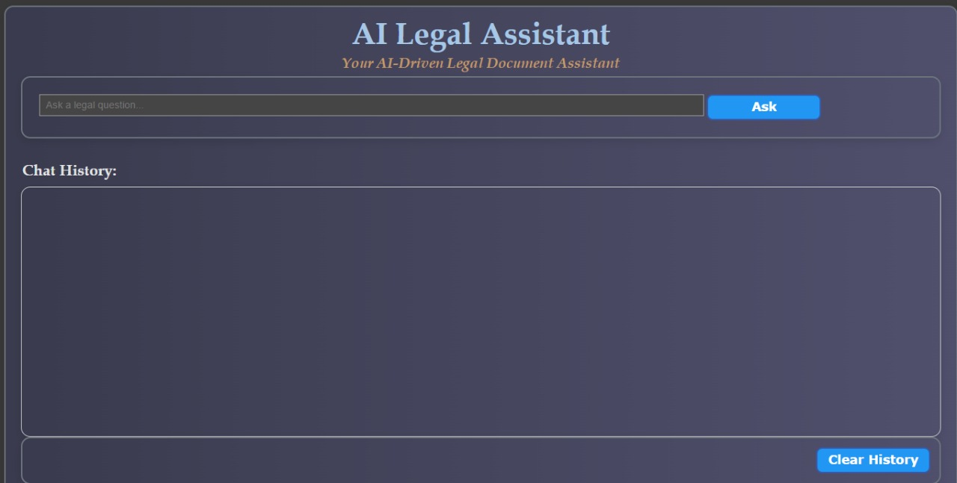**Figure 9.1: AI Chatbot Interface**

Figure 9.1 showcases the user interface of the AI-powered Legal Documentation Assistant. This is the interactive front-end where users can input legal queries and receive contextual responses. At the top, the application is titled **“AI Legal Assistant”**, with a subtitle **“Your AI-Driven Legal Document Assistant”** that briefly communicates the tool’s purpose.

Below the title is a search bar where users can type legal questions, followed by an **"Ask"** button that initiates the query processing workflow. This input is handled by the underlying Python-based backend, which matches the query with relevant sections from the Indian Constitution dataset and returns the appropriate response.

The **"Chat History"** section displays an ongoing dialogue between the user and the AI, maintaining a clear record of all exchanged messages. Additionally, a **"Clear History"** button is available at the bottom right to reset the conversation space, offering a clean slate for new queries. The UI has been designed with a sleek, dark-themed layout that enhances readability and provides a modern, professional look suitable for legal applications.

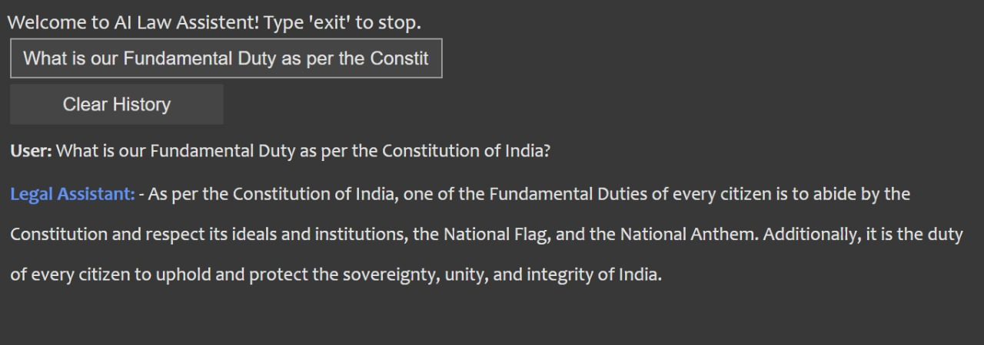This interface plays a crucial role in ensuring smooth and user-friendly interaction, enabling users — especially legal professionals and students — to access legal information quickly and intuitively.

**Figure 9.2: Chatbot responding to a legal query on fundamental rights**

In figure 9.2, the user asked about the Fundamental Duty as per the Constitution of India, and the chatbot responded with an explanation based on constitutional provisions.

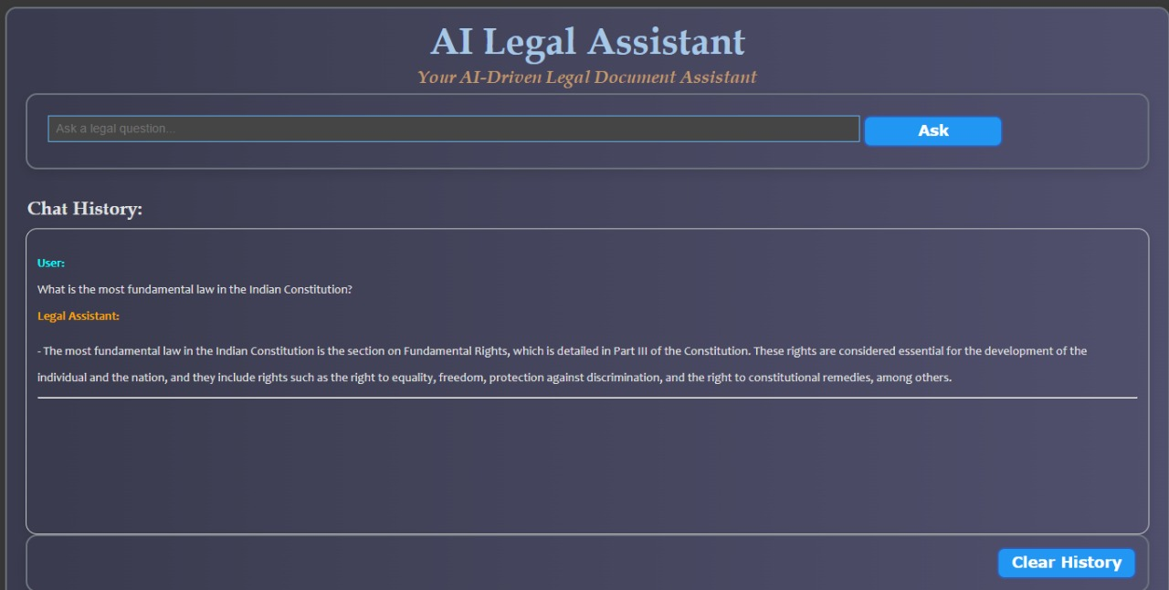  
**Figure 9.3: Response to a query on Fundamental Law by the Assistant**

Figure 9.3 displays the output interface of the AI Legal Word Document Assistant, an AI-powered chatbot designed to assist users with legal queries. At the top, the interface welcomes users with a message and provides an instruction to type 'exit' to stop the interaction. The main section includes a query input field (highlighted in blue), where users can enter their legal questions, along with a submit button that processes the input. Below this, the chat history section displays the conversation between the user and the chatbot. In the image shown, the user asked about the most fundamental law in the Indian Constitution, and the chatbot responded by explaining that Fundamental Rights, enshrined in Part III of the Constitution, form its cornerstone. The response is generated through a document-based retrieval system. When a user enters a query, the system first extracts and preprocesses legal text from PDF files using PyMuPDF (Fitz). The text is structured into headings and corresponding content, allowing the system to efficiently search for relevant information. When a query is received, it is processed to identify key terms and matched against the extracted legal text. The system primarily relies on keyword-based search and text-matching techniques to locate relevant sections. The retrieved information is then formatted into a structured response and displayed.

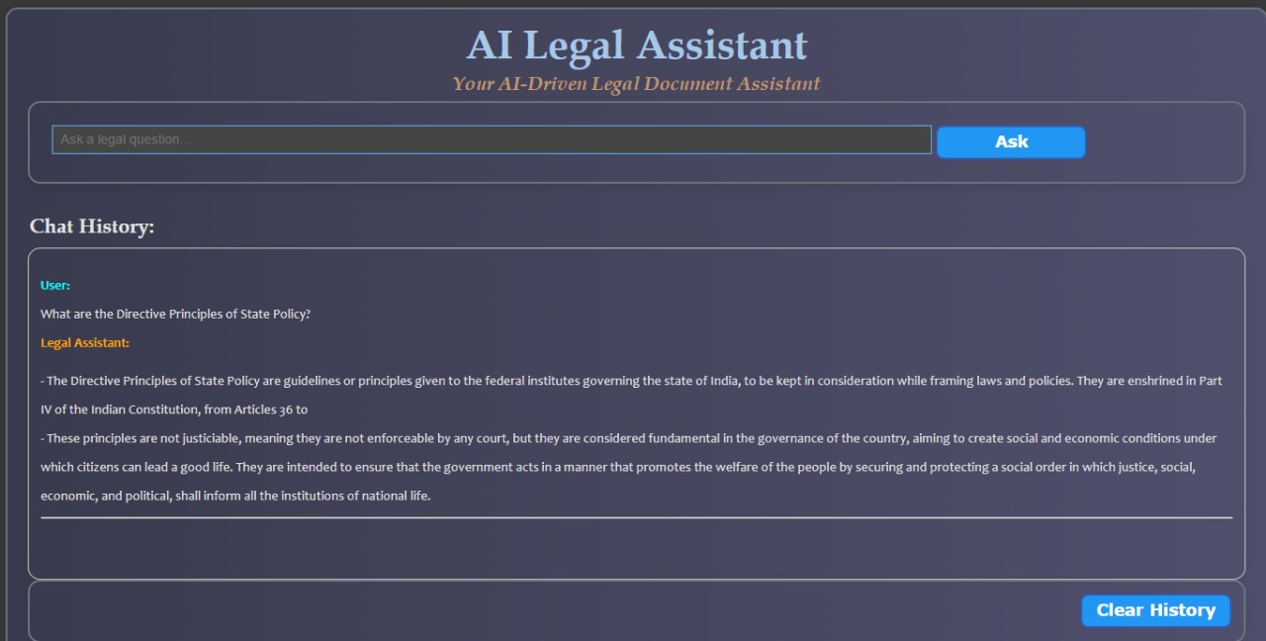**Figure 9.4: Response to a query on Directive Principles by the Assistant**

In figure 9.4, the user asked about the Directive Principles of State Policy. The chatbot answered this question comprehensively citing that Part IV of the Constitution of India lays down the Directives Principles of State Policy (DPSP), which are meant to be followed for governance in India.

**CHAPTER - 10**

**CONCLUSION**

The AI-powered Legal Documentation Assistant represents a significant leap forward in the automation and streamlining of legal processes through the deployment of cutting-edge Natural Language Processing (NLP) technologies. Built to support legal professionals, organizations, and citizens alike, the system is designed for fast, accurate, and contextual retrieval of legal clauses and related documentation from a proprietary legal knowledge base. At the core of this solution lies vector-based similarity matching powered by sentence embeddings and FAISS (Facebook AI Similarity Search) indexing. These technologies enable rapid clause extraction and intelligent question answering by comparing textual content at the semantic level rather than through traditional keyword-based methods. This approach dramatically improves the relevance and accuracy of legal information retrieval, ensuring that users receive the most pertinent results within seconds.

The performance of the assistant is measured using industry-standard metrics such as precision, recall, and relevance scores, ensuring that the outputs are not only fast but also highly reliable. This is critical in the legal domain where the accuracy of information can significantly affect case outcomes and legal interpretations.

To further enhance the system’s understanding of complex legal language, advanced legal text pre-processing methods are employed. These include Named Entity Recognition (NER) to identify legal entities, lemmatization to reduce words to their base forms, and stop word removal to eliminate irrelevant terms. These processes optimize the model’s comprehension and ensure that the assistant can interpret legal documents in their proper context.

Security and compliance are foundational to the system’s architecture. All user data is protected through robust encryption methods and anonymization techniques, aligning the assistant with global legal and ethical standards regarding data privacy and confidentiality.

Looking ahead, the assistant’s roadmap includes the integration of multilingual support, allowing users to access and query legal documents across various languages. This feature is particularly valuable in international law firms and multicultural jurisdictions. Furthermore, the incorporation of real-time validation by certified legal professionals will enhance the system’s credibility and ensure continued legal compliance.

In conclusion, the AI-powered Legal Documentation Assistant offers a revolutionary tool for the legal industry. By drastically reducing the time and effort needed to retrieve relevant legal clauses and supporting documents, it empowers users with faster decision-making capabilities and bridges the gap between legal expertise and technological innovation.

**REFERENCES**

[1]. Rithik Raj Pandey, Sarthak Khandelwal, Satyam Srivastava, Yash Triyar and Mrs. Muquitha Almas, “LegalSeva: AI - Powered Legal Documentation Assistant”, International Research Journal of Modernization in Engineering Technology and Science, vol. 06/Issue: 03, March 2024.

[2]. Imogen Vimala, Sreenidhi J. and Nivedha V, “AI - Powered Legal Documentation Assistant”, Journal of Artificial Intelligence and Capsule Networks. 6. 210-226. 10.36548/jaicn.2024.2.007.

[3]. Awez Shaikh, Rizvi Mohd Farhan, Zahid Zakir Hussain and Shaikh Azlaan, "AI - Powered Legal Documentation Assistant", International Journal of Emerging Technologies and Innovative Research ([www.jetir.org](https://www.jetir.org)), ISSN: 2349-5162, Vol.11, Issue 4, page no. k526-k530, April-2024.

[4]. G. Kiran Kumar, A. Shreyan, G. Harini, M. Balaram, (2024), “AI - Powered Legal Documentation Assistant”, International Journal of Engineering Innovations and Management Strategies 1 (1):1-13.

[5]. Lalita Panika, Aastha Gracy, Abhishek Khare, Sanket Mathur and S. Hariharan Reddy, “SimpliLegal: An AI - Powered Legal Document Assistant”, International Research Journal of Modernization in Engineering Technology and Science, vol. 06/Issue: 04, April 2024.

[6]. M. E. Kauffman and M. N. Soares, "AI in legal services: New trends in AI-enabled legal services," Service Oriented Computing and Applications, vol. 14, pp. 223–226, Oct. 2020, doi: 10.1007/s11761-020-00305-x.

[7]. S. Kapoor, P. Henderson, and A. Narayanan, "Promises and pitfalls of artificial intelligence for legal applications," arXiv, Feb. 6, 2024.

[8]. L. B. Eliot, "AI and Legal Argumentation: Aligning the Autonomous Levels of AI Legal Reasoning," arXiv preprint arXiv: 2009.11180, 2020.

[9]. J. Cui, M. Ning, Z. Li, B. Chen, Y. Yan, H. Li, B. Ling, Y. Tian, and L. Yuan, "Chatlaw: A Multi-Agent Collaborative Legal Assistant with Knowledge Graph Enhanced Mixture-of-Experts Large Language Model," arXiv preprint arXiv:2306.16092, May 2024.

[10]. Q. Steenhuis, D. Colarusso, and B. Willey, "Weaving Pathways for Justice with GPT: LLM-driven Automated Drafting of Interactive Legal Applications," arXiv preprint arXiv: 2312.09198, Dec. 2023.

[11]. D. Shah, J. Vasi, T. Gandhi, and K. Dabre, "AI & ML Based Legal Assistant," International Research Journal of Engineering and Technology (IRJET), vol. 11, no. 07, pp. 706-708, Jul. 2024.

[12]. J. Aroraa, T. Patankara, A. Shaha, and S. Joshia, "Artificial Intelligence as Legal Research Assistant," in Forum for Information Retrieval Evaluation (FIRE), Hyderabad, India, Dec. 2020.

[13]. P. N. Devaraj, R. T. P. V, M. K. R, and A. Gangrade, "Development of a Legal Document AI-Chatbot," School of Computer Science and Engineering, Vellore Institute of Technology, Chennai, India.

[14]. J. Lai, W. Gan, J. Wu, Z. Qi, and P. S. Yu, "Large Language Models in Law: A Survey," arXiv preprint, arXiv: 2312.03718, Nov. 2023.

[15]. Nguyen, H. T., "A Brief Report on LawGPT 1.0: A Virtual Legal Assistant Based on GPT-3," arXiv preprint arXiv: 2302.05729v2, 2023.

**APPENDIX-A**

**PSUEDOCODE**

### # Step 1: Import Necessary Libraries

**Import libraries:**

* pandas, numpy for data handling and preprocessing
* sklearn:
  + PCA for dimensionality reduction
* faiss, HNSWLib or similar for vector similarity search
* transformers from HuggingFace for sentence embeddings
* PyMuPDF (fitz) for extracting text from legal PDFs

### # Step 2: Load and Explore Legal Datasets

**LOAD datasets:**

* Case law documents (PDF)
* Statutes and Acts (state and national level)

**INSPECT data:**

* Extract and clean raw text from legal documents
* Display document types and structure
* Check completeness and formatting consistency

### # Step 3: Data Preprocessing

**FOR each document:**

* Apply PyMuPDF or similar tool to extract text from files
* Clean text:
  + Remove special characters, punctuation
  + Tokenize sentences and words
  + Remove stopwords
  + Apply lemmatization

**Store** cleaned documents with metadata in a structured format (CSV)

### # Step 4: Embedding Generation and Indexing

**GENERATE embeddings:**

* Use transformers to convert text to vectors
* Apply PCA for dimensionality reduction
* Store embeddings in FAISS or HNSW for similarity search

**BUILD vector index:**

* Index all document embeddings
* Enable fast similarity search for user queries

### # Step 5: Chatbot and Query Handling

**START chatbot session:**

* Wait for user input via web or terminal interface
* Process user query:
  + Convert query to vector embedding
  + Match with stored document vectors
  + Retrieve top relevant documents

**DISPLAY response:**

* Return simplified summary or full legal document
* Highlight relevant clauses based on query intent
* **END session** when user types "exit"

**APPENDIX - B**

**ENCLOSURES**

**Figure AB.1: Sustainable Development Goals (SDG)**

Figure AB.1 represents the United Nations Sustainable Development Goals (SDGs), a set of 17 global objectives designed to address social, economic, and environmental challenges. These goals aim to eradicate poverty, promote health, education, and gender equality, ensure clean water and energy, and drive sustainable economic growth. They also focus on reducing inequalities, building sustainable cities, combating climate change, and preserving life on land and water. Additionally, the SDGs emphasize peace, justice, and strong institutions while fostering global partnerships for sustainable development. Together, these goals provide a roadmap for a more inclusive, equitable, and sustainable future.

**1. SDG 16: Peace, Justice and Strong Institutions**

Our project strengthens justice and legal institutions by making legal knowledge more accessible and understandable to the public. It empowers citizens to exercise their rights, understand legal procedures, and access justice digitally, especially those with limited resources.

**2. SDG 10: Reduced Inequalities**

By offering free and easy-to-use legal assistance, our project helps bridge the gap between those who can afford legal services and those who cannot. It reduces inequalities in access to justice and legal literacy, supporting inclusion and social equity.

**3. SDG 9: Industry, Innovation and Infrastructure**

Our AI-powered legal assistant introduces innovation in the legal sector, promoting digital transformation. It builds intelligent infrastructure for legal services and fosters growth in AI-driven legal tech solutions.

**4. SDG 4: Quality Education**

The project contributes to legal education by helping users learn about constitutional rights, laws, and legal terms. It supports lifelong learning and awareness, especially in academic and community learning environments.

**1. Journal publication/Conference Paper Presented Certificates of all students.**

**2. Include certificate(s) of any Achievement/Award won in any project-related event.**

**3. Similarity Index / Plagiarism Check report clearly showing the Percentage (%). No need for a page-wise explanation.**

**4.** **Details of mapping the project with the Sustainable Development Goals (SDGs).**